Runtime Complexity & The Big O

Prioritize time - Take a few minutes to go into your 1:1 doc and set your time priorities for the week!

The Big O & Runtime Complexity
It’s the amount of time an algorithm takes to run as a function based on the size of the input. This can help you answer questions like “if my input size doubles, how much longer will my code take to run?”.

First, it is important to note that Big-O is a mathematical function that determines a portion of time or space dependant on the size of the algorithm as its input. It denotes how long an algorithm will take to execute. Big-O Notation is represented as a function: O(f(n))

⚠️Note: You will be asked about runtime in tech interviews, so you must know how to calculate it.
Constant time — O(1)
- No matter how large your input size it your program will all execute in the same amount of time
Linear time - O(n)
- The runtime grows at the same pace as increased input. Think of a single for loop
Quadratic time — O(n²)
- The runtime squares itself, think of nested for loops
Logarithmic complexity — O(log n)
- Don’t worry about this one too much yet, this will come into play when we get into binary searches
Exponential time — O(2^{n})

This doesn’t tell you how fast your program will run -- just how it will scale with input.
E.g. a program that *always* takes 1 hour no matter what input you give it is “constant time” (or O(1)) but that would still be very slow!

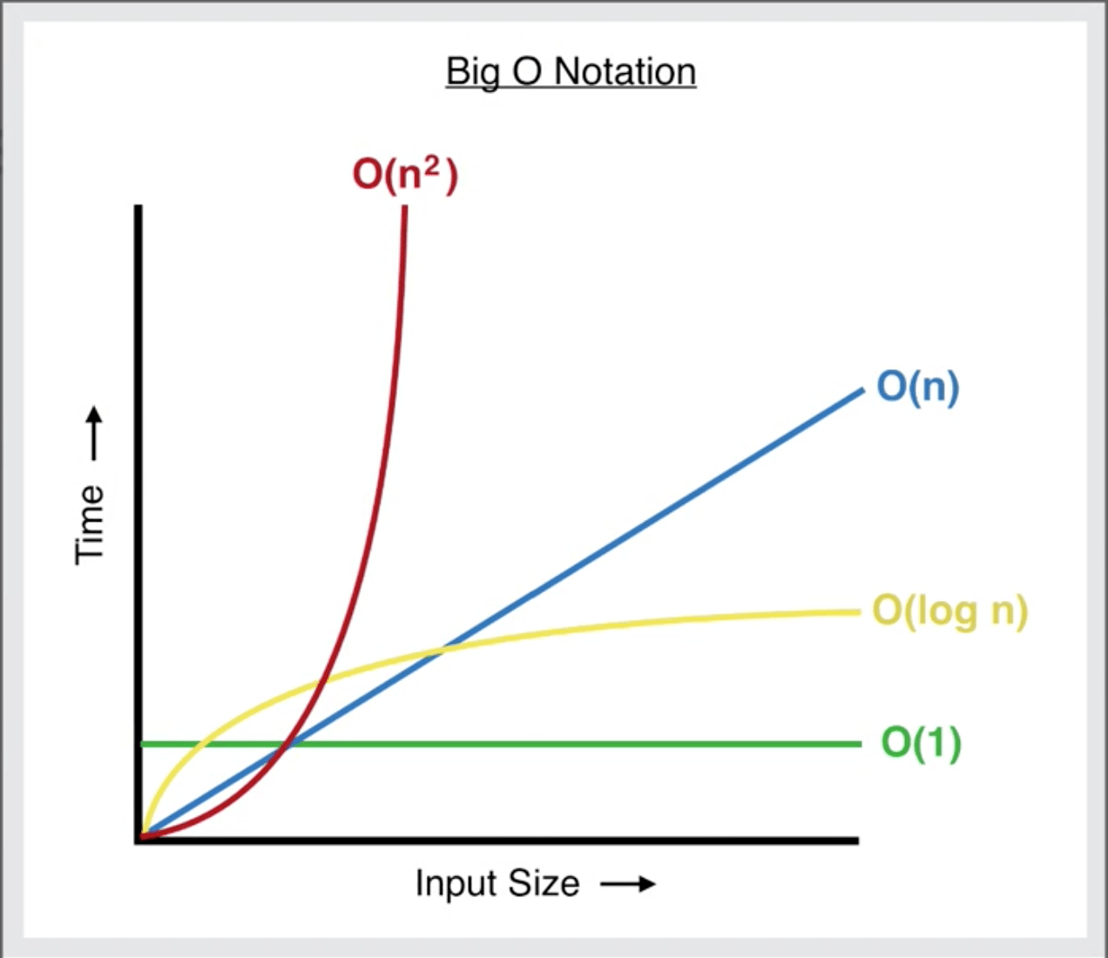

Javascript!
We will be doing a review of some fundamentals in Javascript:
- Conditionals (if-else statements)
- Loops
- Booleans
Make sure that you feel comfortable doing the exercises with these fundamentals. At this point, you should be able to explain how these logics work in Javascript and in what cases you should use these methods to solve problems. Feel free to use any of the books that we suggest. Or new ones. The important thing is that you code along. Practice doing the exercises. Don’t just read the code.

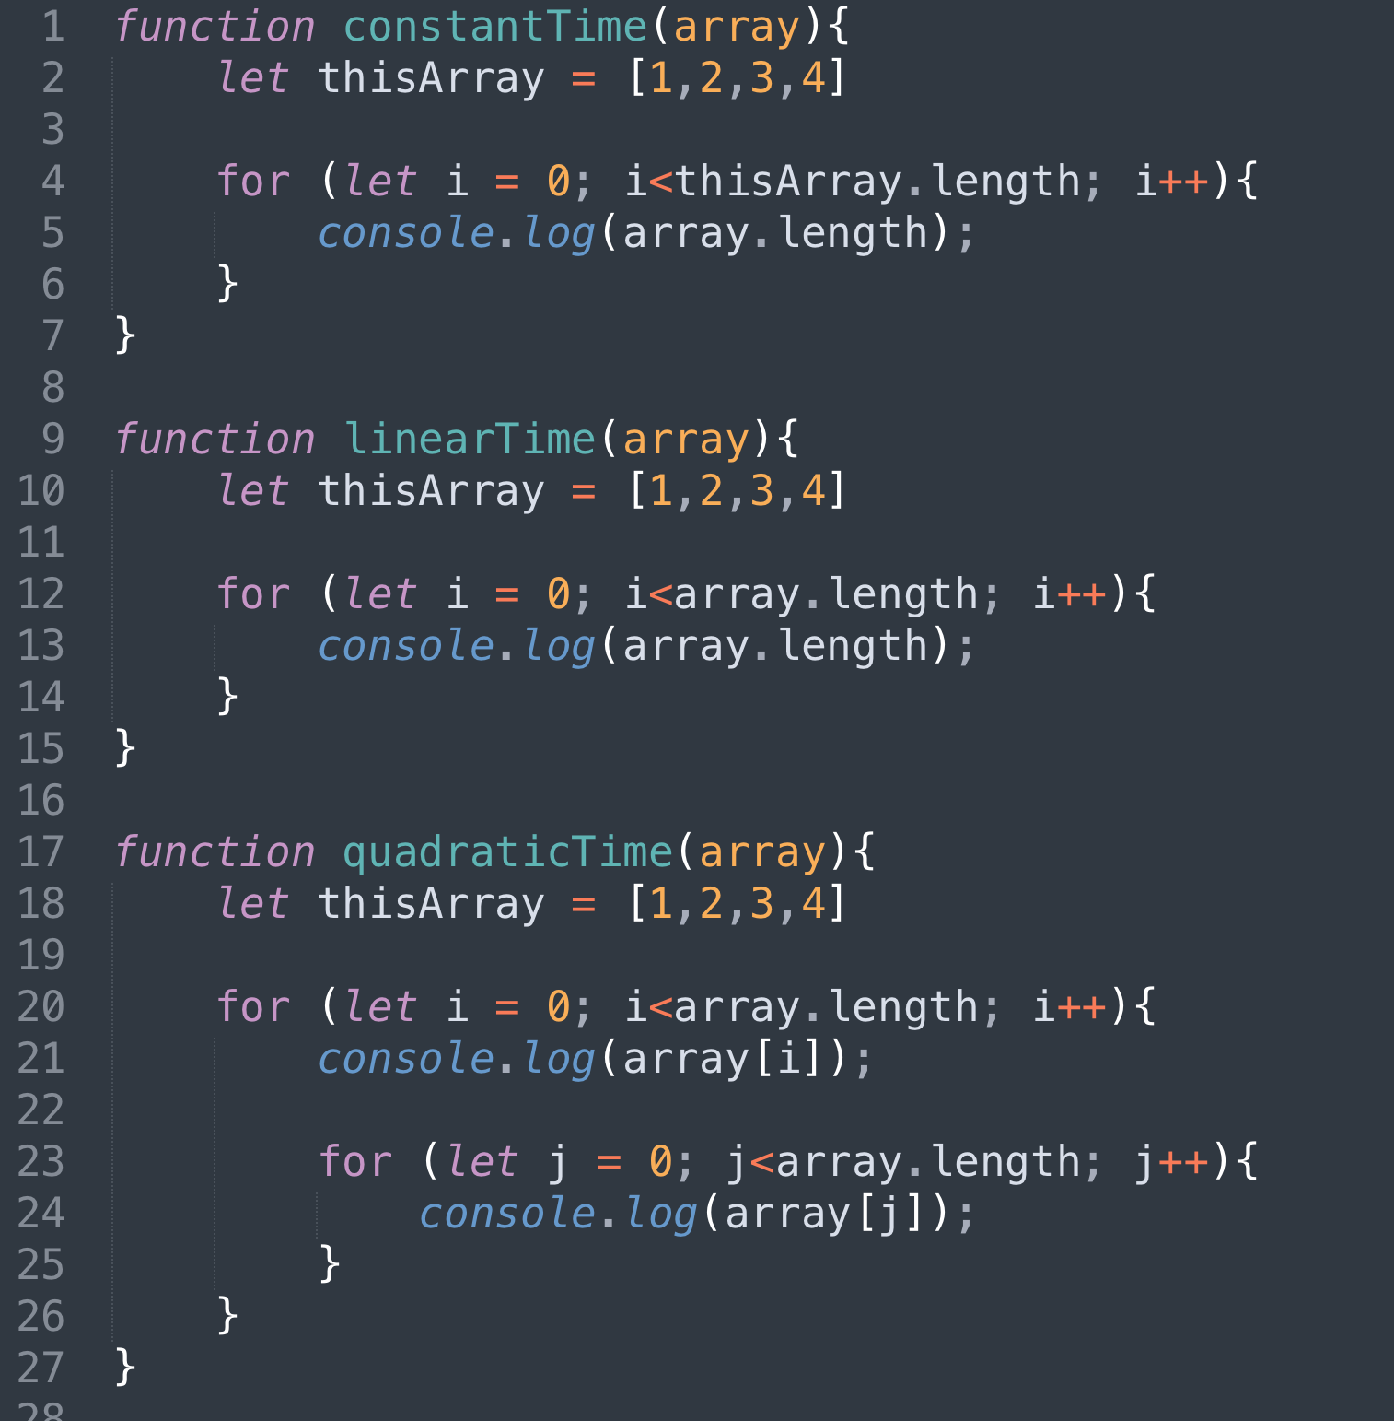

An important takeaway from this practice (try to get memorized):
- Can you write the basic syntax of a for loop, a while loop, an if-else statement?
- Can you convert the given while loop to a for loop:

Review Git - Github!
Git is great to control your version of code, but in addition to Github, it’s perfect to share your code!. Let’s start practicing sharing your code. This week talk with your mentor and see if you can share your project with them via Github.

Weekly Project & Expectations (you will share next Friday)
You are going to make your first profile page! You can think of it as your first online resume. Add contact information for yourself, links to your social media accounts, info about yourself. Here is an example of a basic portfolio. Think of something like this, but do it better, make sure to add info about yourself!

- Part 1: build your basic CSS & HTML — you will build your basic site with your photo, links to your social media accounts, contact info about yourself. You will add a contact form asking for a name (required), email (required), phone number (not required), address (not required). “Not required” means the fields need to be present on the form, but they do not need to be filled out in order to submit the form.
- Part 2: incorporate SEO and a11y principles
- Part 3: you will also work on your collaboration and review.

You will need to review the Branching & PR Instructions doc to help guide you through making a proper pull request like a real software engineer! You should have at least one pull request and should have 50+ commits.

Technical Requirement - you must utilize time management to decide how and when you will implement these

CSS
- At least 3 style properties applied to text
- Border
- Use of columns
- Use of at least 1 ID
- Use of at least 3 web design patterns
- Override a CSS rule in your code in an obvious way at least once
- Change display property of at least 1 element
- Have at least 1 style change for narrow, medium, and wide browser views

HTML
- Headers
- Sections
- Semantic Tags
- Contact Form with required fields
- Links to social media accounts
- Add contact information for yourself
- Photo

Related Resources
⚙️Advanced Command Line
⚙️Runtime Complexity
📽️Time Management

End-of-day questions:

Runtime Complexity
- What is runtime complexity?
- How do we talk about runtime complexity?
- Give me an example of each the following run times: Constant, linear, O(n^2)
- Given a small text snippet try to explain what the run time complexity is.

Git/Github
- Please define the terminal, bash, zsh, git. How are they similar, how are they different?

